Nama : Irviani Syaiful Putri

NPM : 09.2020.1.00693

**QUIS 1 DESAIN IPAL**

1. **Soal 1**
2. Contoh-contoh diagram alir tahapan pengolahan air limbah

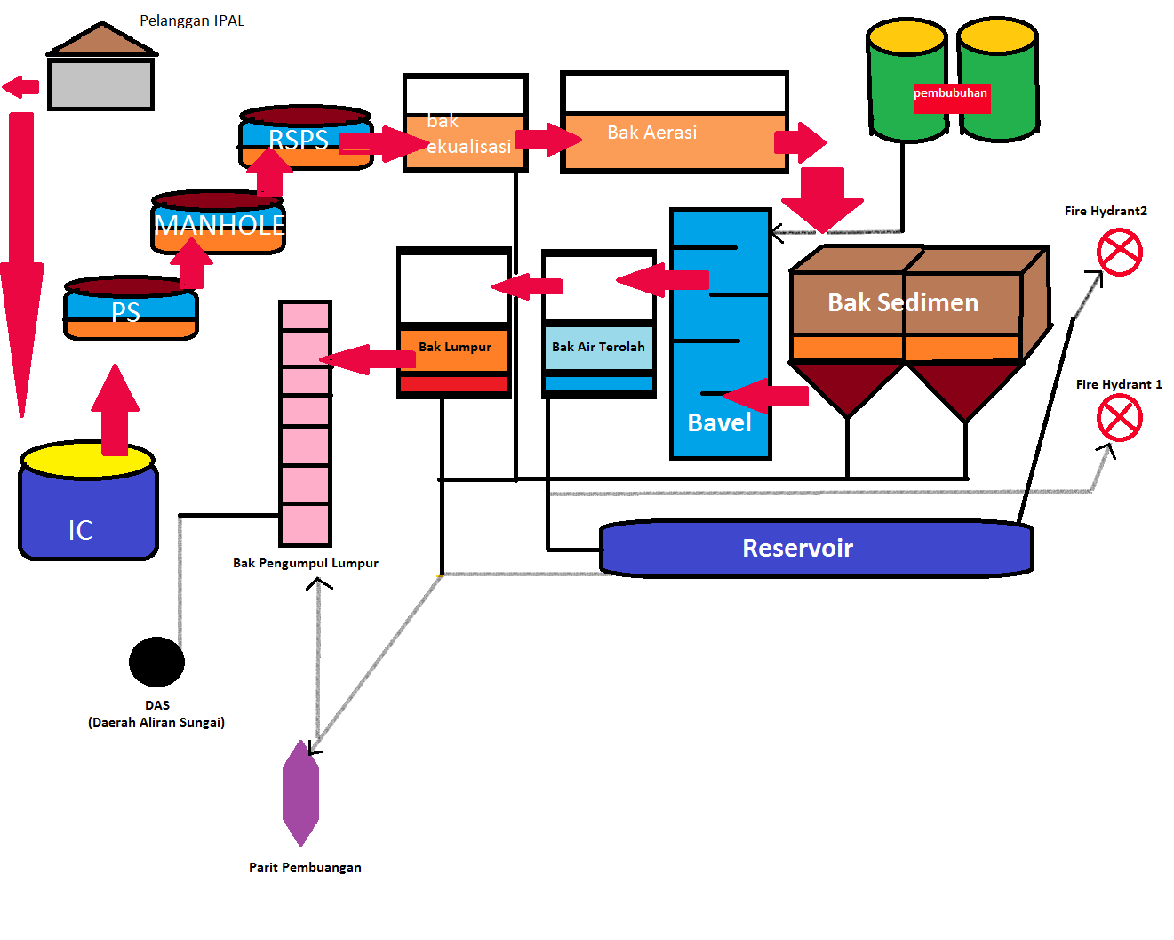

**Gambar 1.** <https://2.bp.blogspot.com/-Sk-e2WfxLP4/WpCl9ElE3iI/AAAAAAAAEwo/46teVepC77g1X3GZJ6_tAxF37Hh7ymX1ACLcBGAs/s1600/IPAL.png>

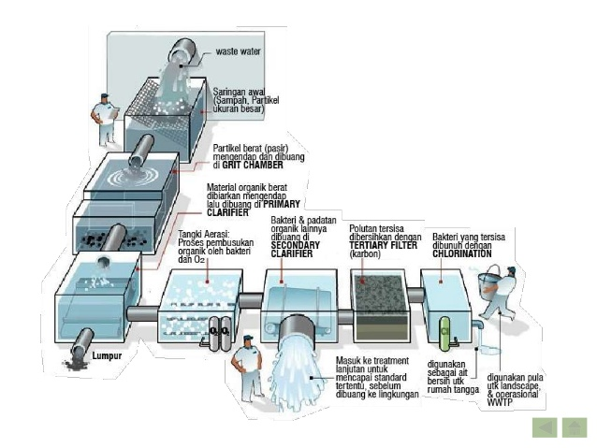

**Gambar 2.** [**https://materikimia.com/wp-content/uploads/2019/02/Skema-IPAL-Instalasi-Pengolahan-Air-Limbah.jpg**](https://materikimia.com/wp-content/uploads/2019/02/Skema-IPAL-Instalasi-Pengolahan-Air-Limbah.jpg)

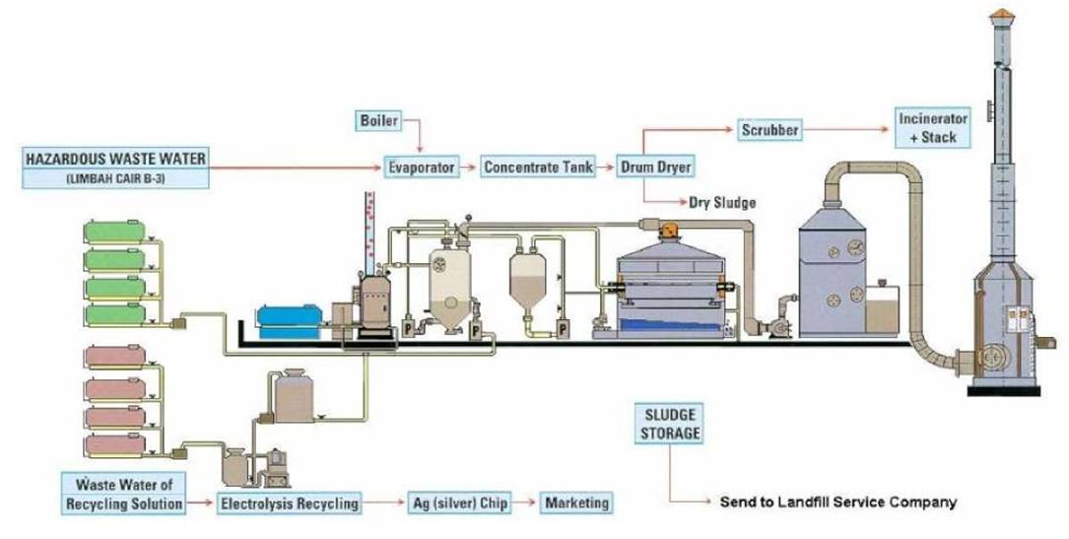

**Gambar3.** <https://th.bing.com/th/id/R.199c683b4bae6fabc13af4ec47fe87ef?rik=ytWaqxqZ6gSkEA&riu=http%3a%2f%2f3.bp.blogspot.com%2f-3MsjAYKSE7M%2fUYi8SiBHmUI%2fAAAAAAAAAQY%2f1it9qygqpf8%2fs1600%2fpengolahan-limbah-industri-percetakan.jpg&ehk=6wo%2b1BAhFzyKLOGaNOArtzlK5Qg%2b9aSvUTrZkAtMiao%3d&risl=&pid=ImgRaw&r=0>

1. Contoh-contoh tata letak bangunan/layout instalasi pengolah air limbah

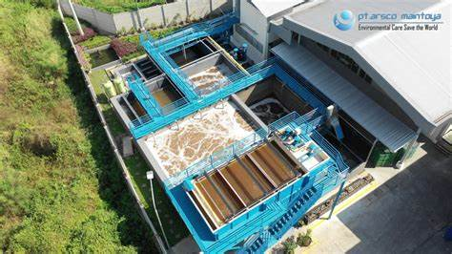

**Gambar 1.** <https://th.bing.com/th/id/OIP.SuIi6dfCHJFypSaV6kEIkwHaEK?pid=ImgDet&rs=1>

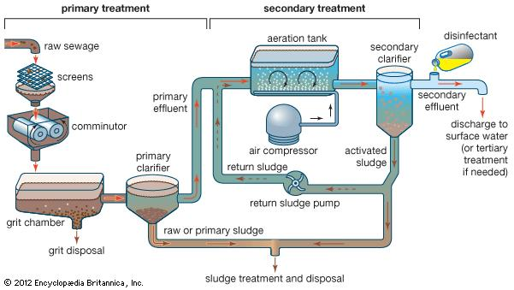gambar 2. <https://th.bing.com/th/id/R.ac9e54adf583af547a5c0fdf856e6bfb?rik=O9PGcVMgqIUK%2bQ&riu=http%3a%2f%2fmedia-1.web.britannica.com%2feb-media%2f55%2f23955-004-2C395C6A.jpg&ehk=qn8aJ5ksvB2rWnfrV98XJ1xFFbe2169Tm77FeE47%2b%2bU%3d&risl=&pid=ImgRaw&r=0>

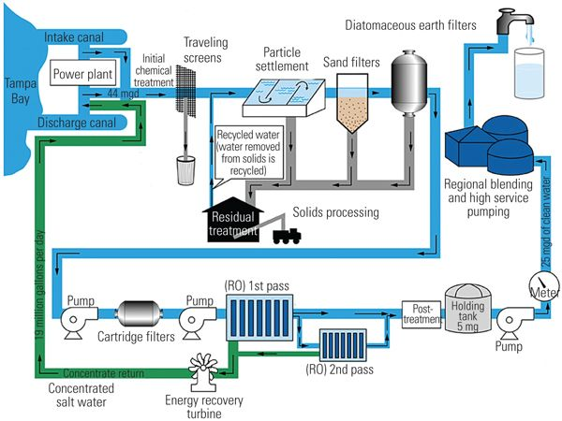

Gambar 3. <https://i.pinimg.com/736x/c8/37/40/c83740243b7db4b583495997f383a9e4--drinking-water.jpg>

1. Contoh-contoh unit bangunan equalisasi/sumur pengumpul instalasi pengolah air limbah

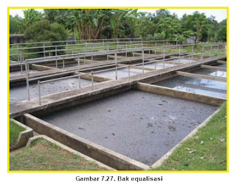

Gambar 1. <https://th.bing.com/th/id/R.ce7592ae8251579093db201f3f9f8d5d?rik=PSlQbNAEhwwBUw&riu=http%3a%2f%2f4.bp.blogspot.com%2f_JL-HawAeuYM%2fSzoJQ2ZUy6I%2fAAAAAAAAAIE%2fpA4JL-8UHGI%2fs320%2fa.jpg&ehk=1hpbsdlacEh0%2fpvb0lAMixxSN7V023GxskMFpC8vp80%3d&risl=&pid=ImgRaw&r=0>

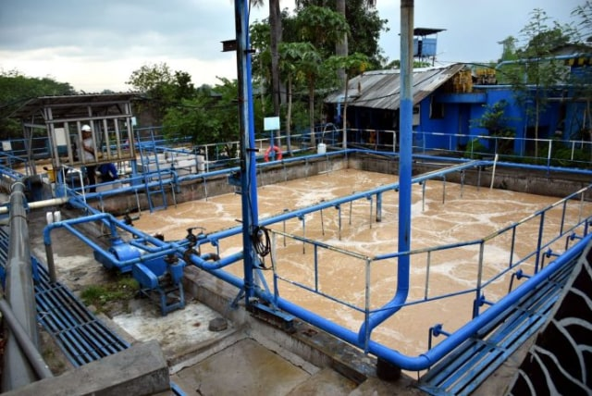

Gambar 2. <https://blue.kumparan.com/image/upload/fl_progressive,fl_lossy,c_fill,q_auto:best,w_640/v1550886466/kqrfvxsasfvbacotqxrw.jpg>

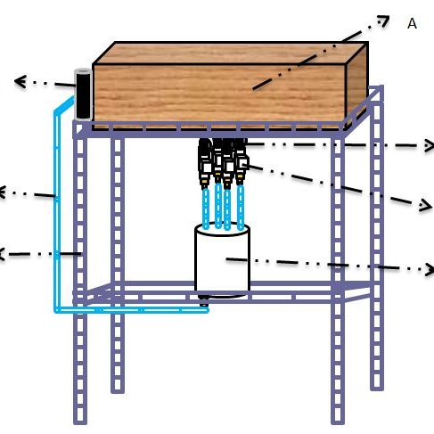

Gambar 3. <https://www.researchgate.net/profile/Diana-Rahmawati-3/publication/345505561/figure/fig1/AS:955645889089539@1604855143919/Desain-alat_Q640.jpg>

1. Contoh-contoh unit bangunan grit chamber instalasi pengolah air limbah



Gambar 1. <https://i2.wp.com/theconstructor.org/wp-content/uploads/2019/10/Grit-Chamber.jpg?fit=731%2C538&ssl=1>

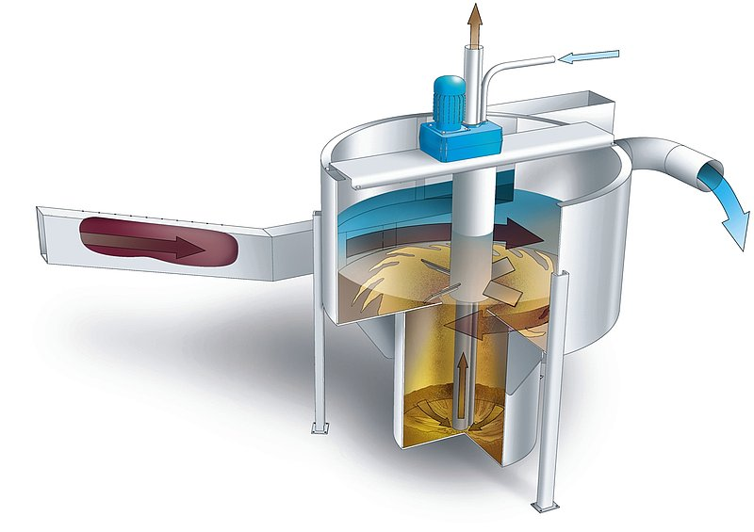

Gambar 2. <https://th.bing.com/th/id/R.f7de65b6fecb585ff94822ab21a72118?rik=pry67BSw9JPR9g&riu=http%3a%2f%2fwww.huber.de%2ffileadmin%2f_processed_%2f4%2f8%2fcsm_skizze_vormax_01_c4f77975ff.jpg&ehk=QnO7CKjKgIusSaNQ6%2bi32xiOp88OgNmZuHY32e89dNw%3d&risl=&pid=ImgRaw&r=0>

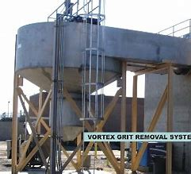

Gambar 3. <https://mytinycozyspace.files.wordpress.com/2013/10/11-vortex-grit-chamber.jpg>

1. **Soal 2**
2. Desainlah bangunan horizontal flow grit chamber

Perhitungan Grit Chamber IPAL

* Debit air limbah = 600 L/detik

= 0,6 m3/detik

* Direncanakan 2 unit grit chamber (beroperasi bergantian)
* Lebar unit (l) diasumsikan 0,75 meter
* Kecepatan horizontal (Vh) = 0,4 m/detik
* Asumsi partikel grit:
* Partikel grit berukuran 100 mesh
* Kecepatan settling (Vs) = 0,8 m/menit = 0,013 m/detik
* Spesific gravity (Sg) = 2,65
* Koefisien k = 0,05
* Koefisien f = 0,02
* Viskositas = 0,8975 × 10-6 m2/detik pada suhu 25°C
* Berat jenis air (ρ) = 1.000 kg/m3
* Dimensi bak
* Cross area (Ac)
* debit atau Q tidak dibagi dua karena penggunaan unit secara bergantian
* Ac =

=

= 1,5 m2

* Kedalaman (h)
* Ac = l × h

2 m2 = 0,75 m × h

* h = $\frac{1,5 m^{2}}{0,75 m}$

= 2 m

* Panjang grit chamber (p)

Panjang (p) = $\frac{Vh × h}{Vs}$

= $\frac{0,3 m/detik ×2 m}{0,013 m/detik}$

= 46,1 meter

* Surface area (AS)

AS = p × l

= 46,1 m × 0,75 m

= 34 m2

* Waktu detensi (td)
* td = $\frac{volume}{Q}$

= $\frac{46,1 m × 0,75 m × 1,5 m}{0,6 m^{3}/detik}$

= 86,4 detik

* td < 60 maka dilakukan perubahan pada dimensi bak:

panjang = 50 m

lebar = 30 m

kedalaman = 15 m

* td = $\frac{volume}{Q}$

= $\frac{50 m × 30 m × 15 m}{0,103 m^{3}/detik}$

= 1730 detik

* Kecepatan scouring (VSC)
* VSC =

=

= 2,54 m/detik

* VSC > Vh **(OK)**
* Grit Storage
* Q air limbah = 0,6 m3/detik × 86400

= 51.840 m3/hari

* Tes lab = 0,01 liter pasir perhari per 1 m3
* Q grit =

= 0,09 m3/hari

Pembersihan dilakukan setiap hari dengan volume total pasir adalah 0,09 m3/hari

* Perencanaan volume dan dimensi ruang pengumpul grit

Gambarkan hasil desain perhitungan saudara